Eating Mimicry Among Family Members

***Keywords: eating, social influence, mimicry, families, public health, micro behavior***

**Background.** Eating behavior is a major driver of chronic diseases such as obesity, diabetes, and many cancers. However, improving eating behaviors has proven very difficult, in part, because eating is typically a *habitual behavior:* it is performed repeatedly in the same contexts and so becomes automated and triggered by cues in the environment (social or physical), rather than internal and conscious cues such as hunger or beliefs (e.g., intentions to eat healthy).1 Eating environments must be a key focus of efforts to promote healthy eating.

Families are an important source of influence on eating: family members often eat with one another, and tend to be similar in their food choice and eating behaviors.2,3 Shared eating behaviors partially result from interpersonal influence, and one important mechanism may be behavioral mimicry: when a person unconsciously, automatically, and immediately mimics the behavior of another. Evidence of *eating mimicry* in strangers and parent-daughter pairs4,5 indicates participants unconsciously mimicked the eating rate and type of food consumed by their eating partner. Eating mimicry can impact health by promoting unhealthy food consumption and/or faster eating rates, which have been linked to increased energy intake.

However, eating mimicry has been understudied in families. This is likely because of the difficulty of studying micro-behaviors in real-life contexts as they unfold, and because health behavior theories have traditionally overemphasized “conscious” and rational social influence mechanisms (e.g., social learning). The objectives of this pilot study are to use videotaped family meals to: (1) test for evidence of bite mimicry among family members during a shared meal; and (2) test if participant characteristics (age, gender, family role) predict dyads exhibiting significant bite mimicry. Findings from this study are being used to inform the development of the Monitoring and Modeling Family Eating Dynamics (M2FED) cyber-physical system that utilizes wrist-worn and in-situ sensors to detect family eating behavior in their homes.6

**Methods.** Thirty-three participants from ten families (each family having 3 or more members that included one child over 11 years old) living in Los Angeles participated in the study, where they were video recorded while eating an unstructured family meal in a kitchen lab setting. Families were provided with a hot meal, snacks, and drinks, and were free to eat as much as they wanted. Participants were told that the purpose of the study was to test the accuracy of the M2FED equipment (smart watches) to detect eating. Family meal sessions were video recorded using the Noldus Media Recorder, and each family member completed a survey to assess their age, gender, and family role (parent, child, etc.). The protocol was approved by the University IRB, and participants were given $15 gift cards as compensation.

Videotapes (three video angles per family; time-synched) were coded to identify and timestamp the bites of each participant (i.e., the moment they placed food or beverage in their mouth). To test for eating mimicry, each family’s timestamped bite dataset (i.e., all bites taken during the eating session) was divided into all of the possible dyad combinations as the unit of analysis (n = 78 dyads, nested in 10 families). Nonparametric permutation tests were used to test for mimicry in each dyad: i.e., to determine if a Participant *i* took a bite *more quickly* after having been exposed to a bite cue by their eating Partner *j*, compared to their bite rate observed during the entire shared eating widow. We calculated the observed average time gap between *i* and *j*’s bites, and this value was compared to a null distribution of the same statistic, generated by randomly permuting the bite intervals (intervals between each bite taken, which, on average, consisted on XYZ per individual) 500,000 times for each individual. For each dyad we compared the observed average time gap with the distribution of the same statistic calculated using the permuted data (simulated eating events). We evaluated the extent to which the observed average time gap was shorter than expected as if by chance, which allowed us to investigate the presence or absence of mimicry at the dyad level. Regression models were fit at the dyad level to determine if any individual or dyadic characteristics predicted significant evidence of mimicry, operationalized as a p-value of <.05 or <.10 from the permutation test.

**Results.** The average eating rate was 3.0 bites per minute (SD=1.0), and children had faster eating rates than parents (3.5 vs. 2.4 bites per minute, respectively; *p*=.003). The average observed time between Person *i*’s bites and Person *j*’s bites was 9.0 seconds (SD=3.9). Nonparametric permutation testing identified five of 78 dyads in which there was significant evidence (*p*<.05) of eating mimicry (Fig. 1). The average observed length of time between Person *i* and *j*’s bites in these five significant dyads was 6.3 seconds (SD=1.7), and in the non-significant dyads was 9.2 seconds (SD=3.9). Nineteen of the 78 dyads had marginally significant evidence for eating mimicry (*p*<.10). The 19 dyads with significant or marginally significant evidence of eating mimicry were a mix of dyad types, and the results of the logistic regression models showed that none of the assessed participant characteristics significantly predicted a dyad’s likelihood to exhibit eating mimicry.

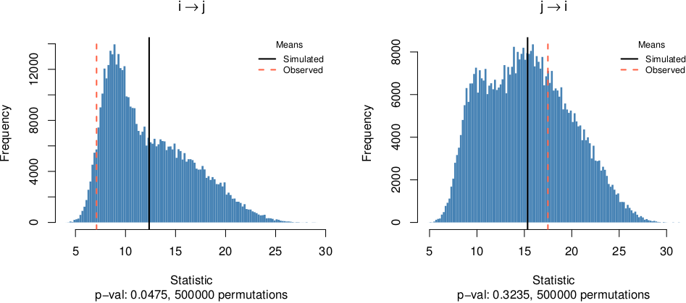

*Figure 1.* Bite distributions for two directed dyads (left: significant, right: non-significant).

**Conclusions**. This pilot study provides preliminary evidence that eating mimicry may occur among a subset of family members, and that there may be types of family ties more prone to this type of interpersonal influence during meals. This expands our understanding of eating behavior in families, which has often been based on static “snapshots” of behavior, and it encourages future work examining the micro-level phenomena of family eating behavior, such as mimicry, in real-time and in “the wild”.

# References

1. Cohen D, Farley TA. Eating as an automatic behavior. *Prev Chronic Dis*. 2008;5(1):A23

2. Ayala GX, et al. Association between family variables and Mexican American children’s dietary behaviors. *J Nutr Educ Behav*. 2007;39(2):62-69

3. Munsch S, et al. Restrained eating in overweight children: Does eating style run in families? *Int J Pediatr Obes*. 2007;2(2):97-103

4. Hermans RCJ, et al. Mimicry of food intake: The dynamic interplay between eating companions*. PLoS One*. 2012;7(2):e31027

5. Sharps M, et al. Examining evidence for behavioural mimicry of parental eating by adolescent females. An observational study. *Appetite*. 2015;89:56-61

6. Spruijt-Metz D, et al. M2FED: Monitoring and Modeling Family Eating Dynamics. Proceedings of the 14th ACM Conference on Embedded Network Sensor Systems; 2016; Stanford, CA, USA

Author information to submit separately:

Kayla de la Haye, PhD

Brooke M. Bell, BA

George G. Vega Yon, MSc, MA

Abu Sayeed Mondol, MS

Ridwan Alam. MS

Meiyi Ma, MS

Ifat Emi, MS

John Lach, PhD

John A. Stankovic, PhD

Donna Spruijt-Metz, PhD, MFA

Guidelines:

* 2 pages maximum (including figure and references)
* Single spaced
* Font – Times New Roman, 12pt
* 1-inch margins
* Do not include author names for blind review and remove any information that may identify the author(s)

Include in Order:

* Paper title
* 5 keywords
* Expanded abstract (= main text) including figure
* References